

Lodha IThink Techno Campus,10th Floor - Beta building,  
Off JVLR, Opp. Kanjurmarg Station,  
Kanjurmarg(E) ,  
Mumbai - 400042

BigFix

**SOP for Patch** Deployment **On Linux systems**

# Deployment of Single / Multiple patches onto the system

If you want to deploy a single patch onto a system or you have found or been instructed to deploy a single vulnerability patch onto a single system then then by the below given process you can deploy.

You can also deploy multiple patches onto a single machine by this process, but it is not the best practice. The best practice to deploy multiple patches is first create a baseline of those patches and then creating a baseline

To deploy a single patch onto a single machine, kindly follow the below steps.

Before deploying patches whether single or by using baseline you need to import GPG key for each and every server. For that you need to go in Fixlets and tasks and search gpg

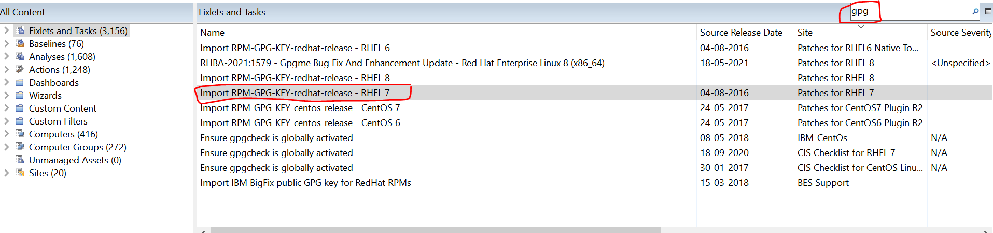

You need to select the Import GPG key OS wise > Take action > Enter device names > enter the list of names > Exceution > select start date and time, end date date and time. Also click the checkbox containing “ **Start client download before contraints are satisfied”**

This must be done each and every time you deploy patches on a single machine or by baselines.

1. Kindly log in onto the BigFix console, once you log in into the console you will get the below window:

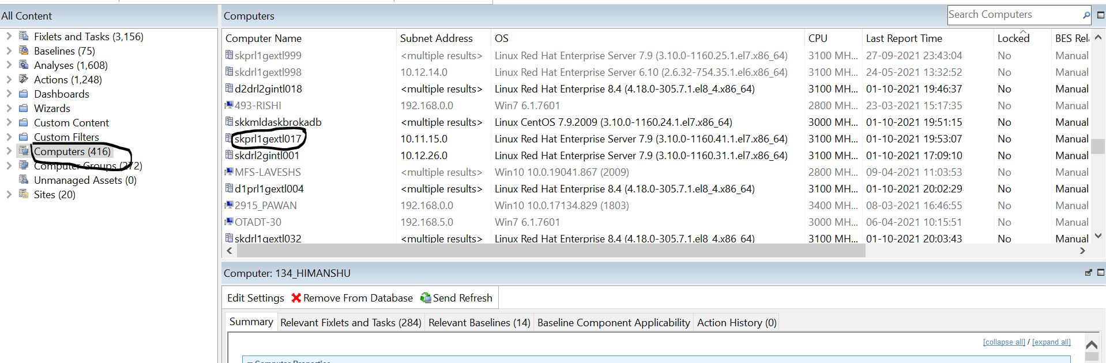

* **Step 1:** Click onto the computers tab which is located onto the middle left side of the console.
* **Step 2:** Select the computer onto which you need to deploy the latest month single patches.

1. Once you have selected the computer / system on which you have to deploy the single patch of the latest month. You will get the details of the system in the summary tab which is located at the middle of the console. You will able to see various tabs in that section, tabs like – Relevant Fixlets and task, Relevant baselines and Action history etc. There you have to select Relevant Fixlets and task.

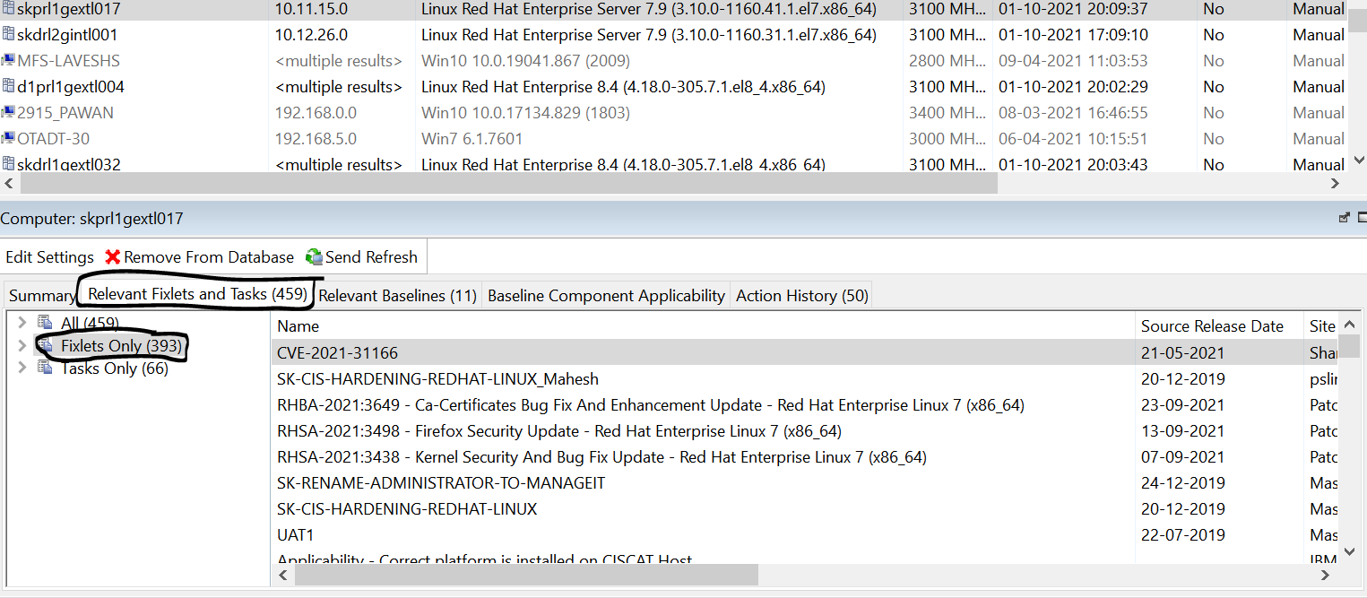

* **Step 3:** In the middle of the BigFix console you will be able to see Relevant Fixlets and task tab kindly select on that tab. Basically this tab will give you the detail information regarding the applicable fixlets and task on that system which you can deploy.
* **Step 4:** Once you click Relevant Fixlets and task tab, on the bottom left side of the window you will be able to see you will be able to see 3 options which are:

**All**–In this tab you will be able to see both Fixlets and Task mixed together which are applicable for this system.

**Fixlets only**- In this tab you will be able to see on fixlets / patch which are applicable for this system.

**Task only**- In this tab you will be able to see only task which are applicable for this system.

Here we have to select **Fixlets only** tab.

1. After selecting Fixlet only tab, you will get an option to expand the tab. Expand the tab

* **Step 5:** Once you have expanded the menu you will get various options like – Source severity, Source release date, Sites etc. In this step you will see various categories by which you can deploy the patch. The below steps are the best practice to deploy a single patch onto a single system.

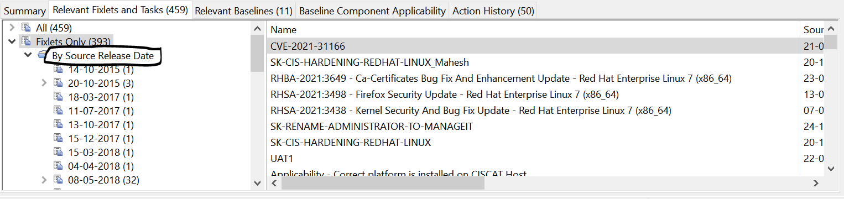

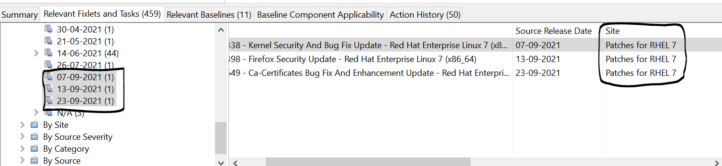

* **Step 6:** After clicking on Source release date you will again get option to expand the menu. After expanding the menu, you will see various source release dates. Here you have apply the latest patches in sync with the baseline.

**Note - On owner request patches beyond baseline can also be applied.**

* **Step 7:** Now once you click on the source release date/s you will see various patches that are applicable for the system.Select all patches and then right click on them, you will see a menu where you need to select “Take default action” meaning that these patches are to be applied now.

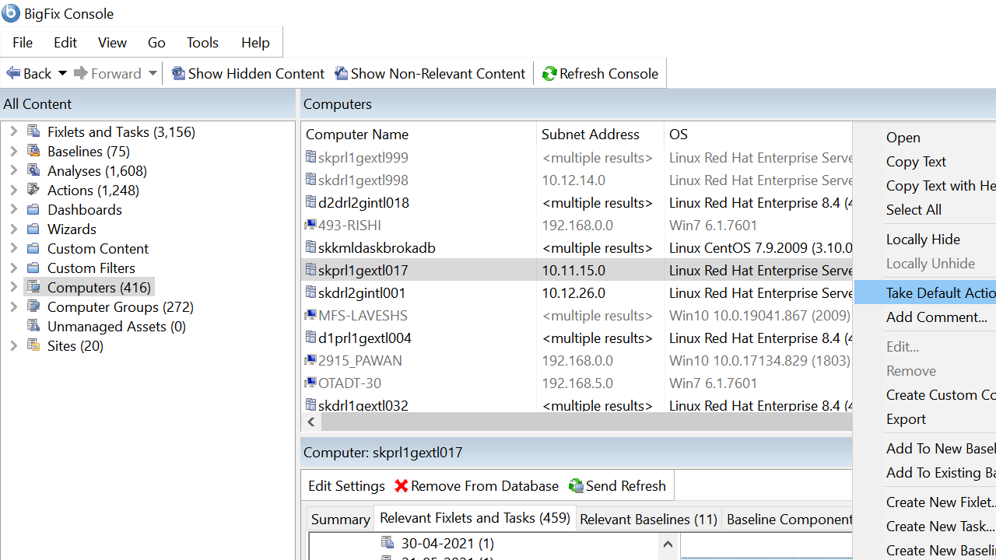

* **Step 8:** Once you click “Take Default Action” a window will pop up showing you that these patches are relevant for which system, so you select the system and then go in the execution tab as shown below to set the start and end time for the patches to get download.

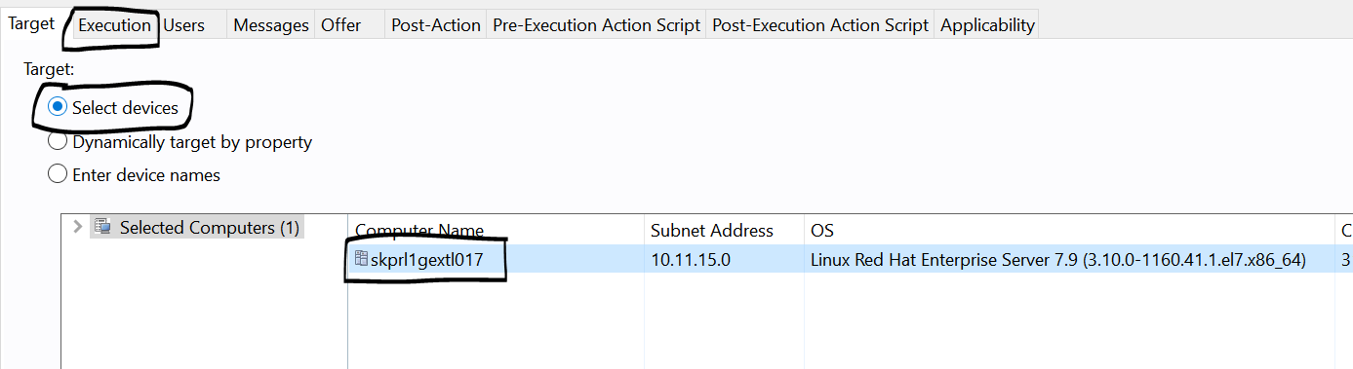

* **Step 9:** In the execution tab, select “Starts on “ check so you get to decide at what date and time the patching should start and end.

Also make sure you select the below check box containing

**“Start client download before contraints are satisfied”**.

Now click on OK.

Once done your patching will start at the desired date and time you have selected.

Note - Single system patches are done after owner provides downtime for the same.

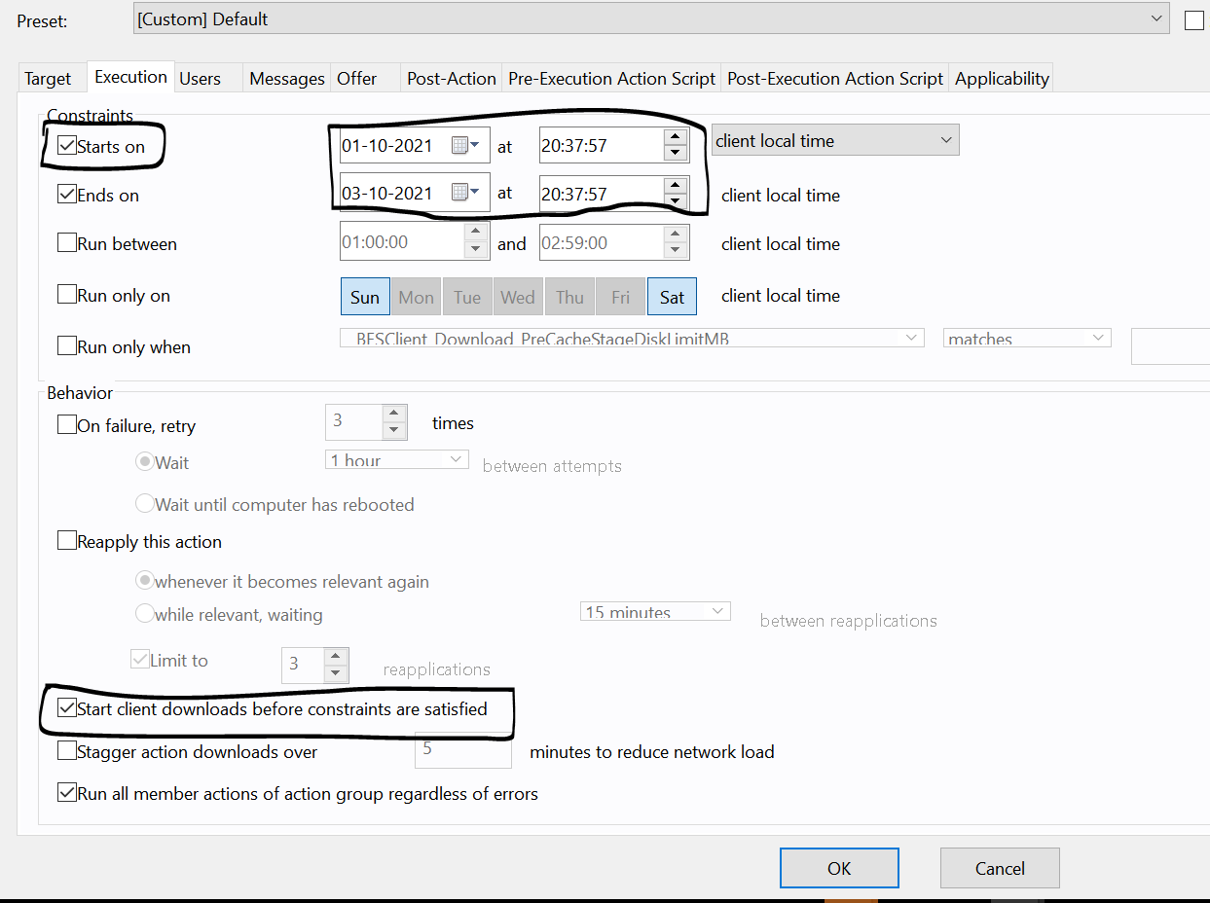

* **Step 10:** Once you click the OK button your patching process is nearly done. Now you have to wait until the patches deployed shows you **completed/fixed** in the action tab.

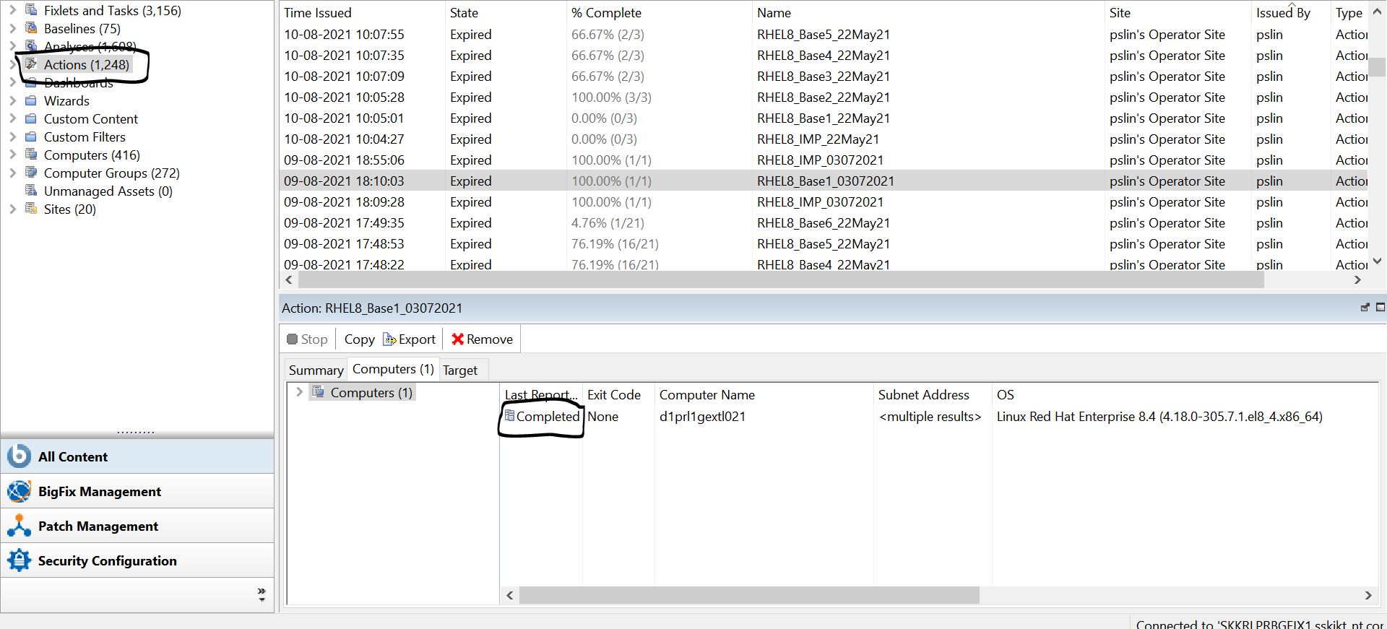

* **Step 11:** The next thing we need to apply is the behaviour of the patch. If the patch gets failed onto the system, how many time does the task should re-apply and it should apply when, after a reboot or after a particular time.

## It is always recommended to re-apply the action 3 times and wait until computer gets rebooted.

# Deployment of Baseline onto one or More system

To create the Baseline Kindly Follow the below steps which are the best practice:

1. Kindly Log in into the BigFix Console.

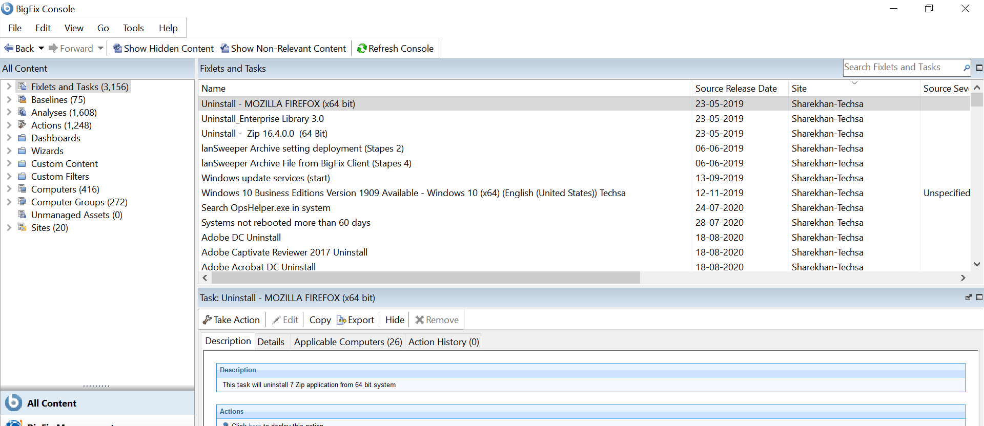

1. In the Left side of the console you will be able to see Fixlets and Task tab, kindly click Fixlets and Task tab. Search “multiple” you will get many options out of which select “Enable the Multiple-Package Baseline Installation feature - RHEL6”

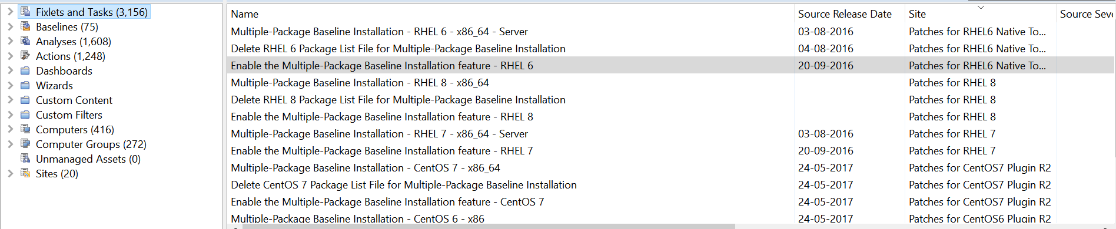

Here we need to select the enable tag OS wise while creating the baseline, here RHEL 6 is just for an example.

1. Now right click on “Enable the Multiple-Package Baseline Installation feature - RHEL7” and click on add to new baseline.

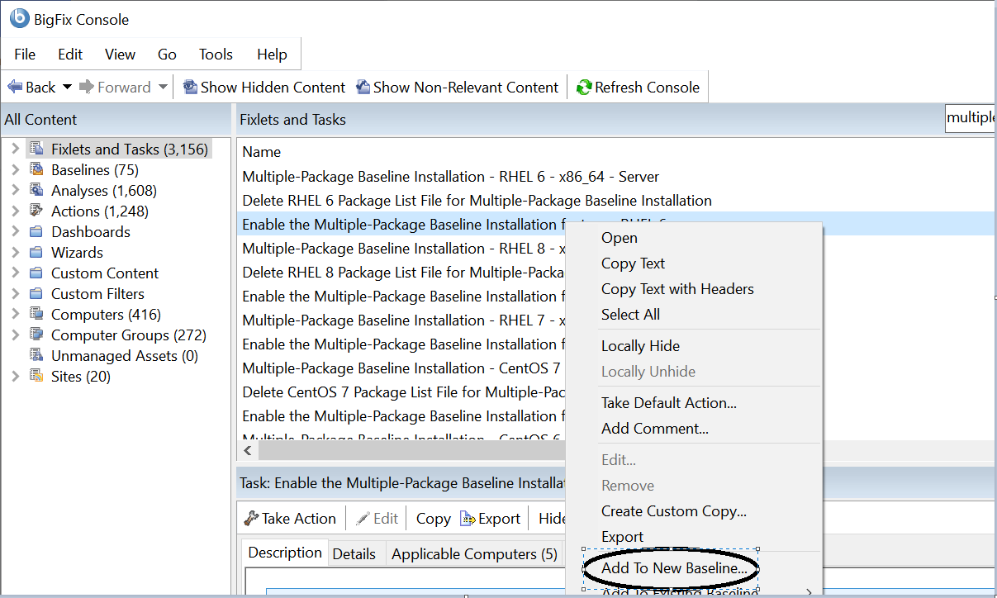

1. After clicking on Add to New Baseline you will see below window, now here you need to add name for your baseline. Best practice to name a baseline is to give OS name and patch date.
2. Patch date means patches upto that date.
3. Also check in components whether the enabler is added or not and click on OK.

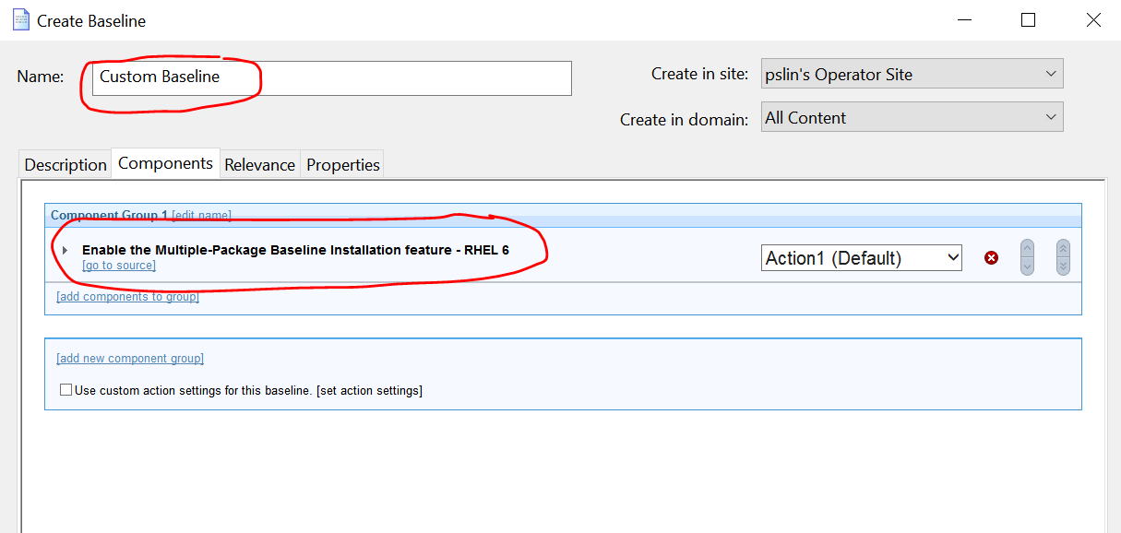

1. Once you have created the baseline its time to add the patches to the same baseline. Now go in Fixlets and Tasks > expand Fixlets Only > By site > Patches for RHEL 7 > By Source Release Date

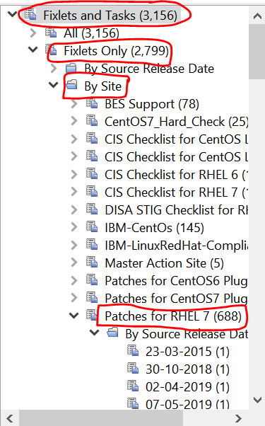

Here we need to follow the above path to add the patches in the baseline.

Once you have the date of last patch cycle you need to add the patches from the next date of that patch cycle

Eg- if the patch are added to specific baseline containing the date 09-08-2021 which means all patches till this date are added in that baseline and now we need to add patches released after that date.

Once this is known click on all the release dates on left hand side,you will see all the patches released on those dates to the right select all the patches and right click on them and click on add to existing baseline.

Here we selected “add to existing baseline” as we have already created the baseline while selecting the enabler package.

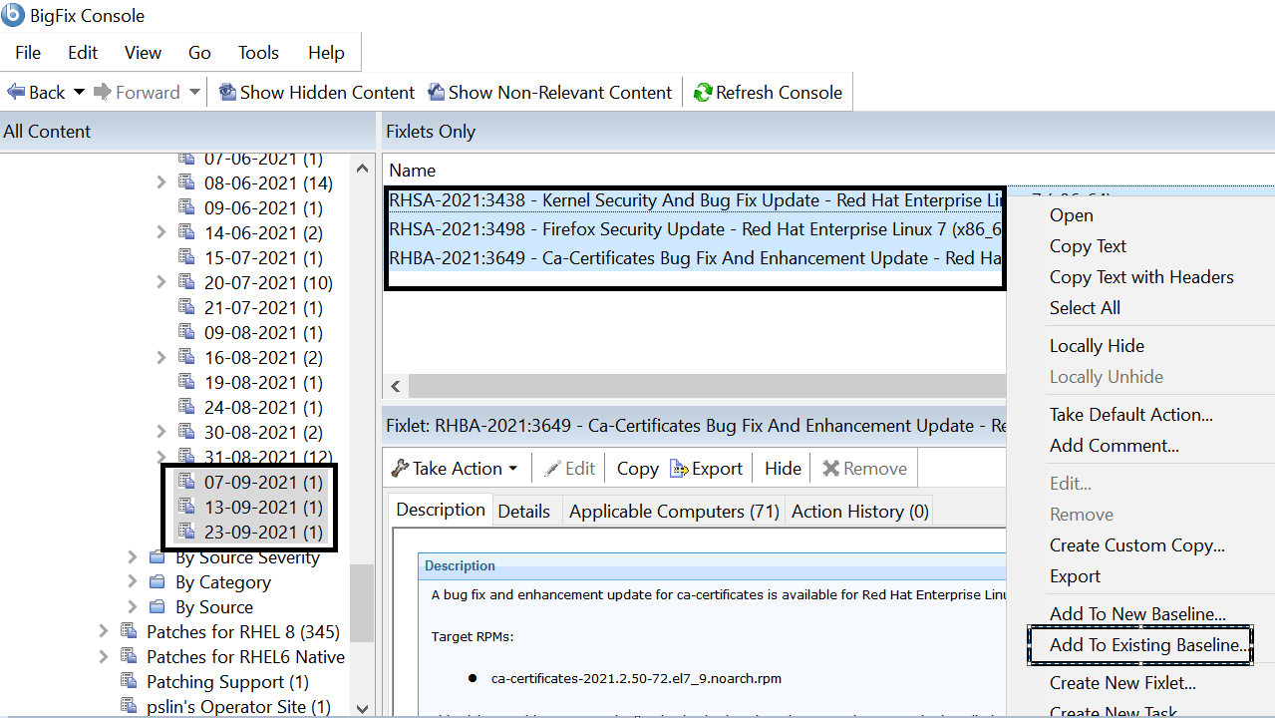

After clicking on “add to existing baseline you will get all the baselines you have created previously.Be careful while you add the packages to the baseline.

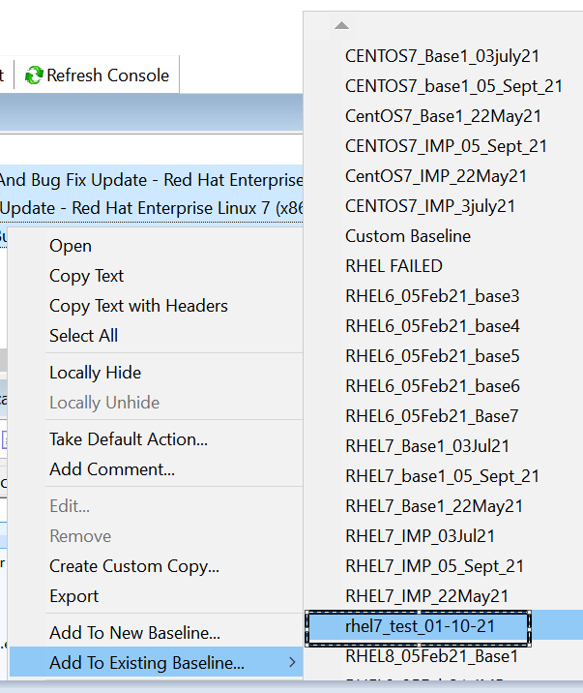

Now you have added the packages to the baseline,click on components where you will see the packages added to the baseline.

At the bottom right you can also see the count of the packages added in the baseline. Once you have added and confirmed that the packages are added click on OK you are nearly there to complete the baseline.

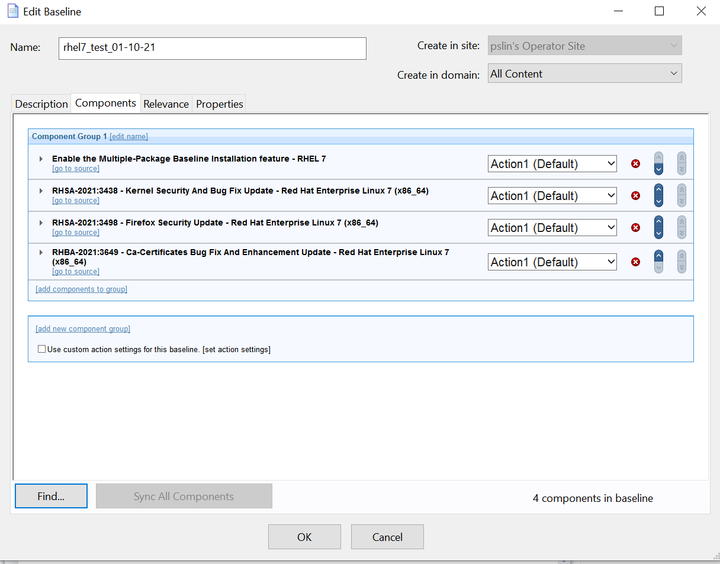

At the end of creating the baseline you need to add the below package to complete the baseline, make sure you don’t forget to add this package and the “Enable the multiple package baseline installation feature” for each and every baseline OS wise.

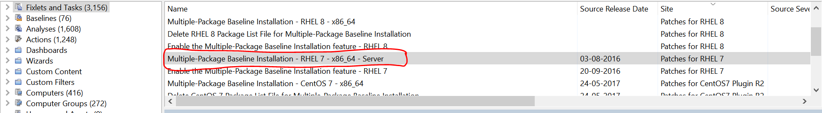

You need to add the package in the same way you have added the packages by right clicking > add to existing baseline > baseline name > OK.

NOTE - Make sure that “Enable the Multiple-Package Baseline Installation feature - <OS>” should be at the very top of the baseline and “Mutliple-Package Baseline Installation -<OS>” should be at the end; all the packages must be ruled between these two components or else the baseline wont work as we want.

Now your baseline is created, now go in the left mini window > Baseline > Search for newly created relevant baseline.

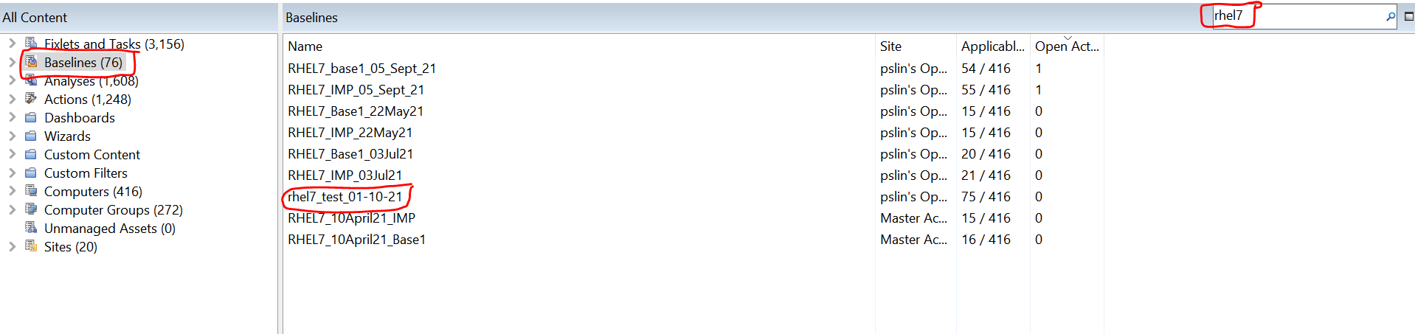

Click on the baseline and then click on Take Action as shown below.

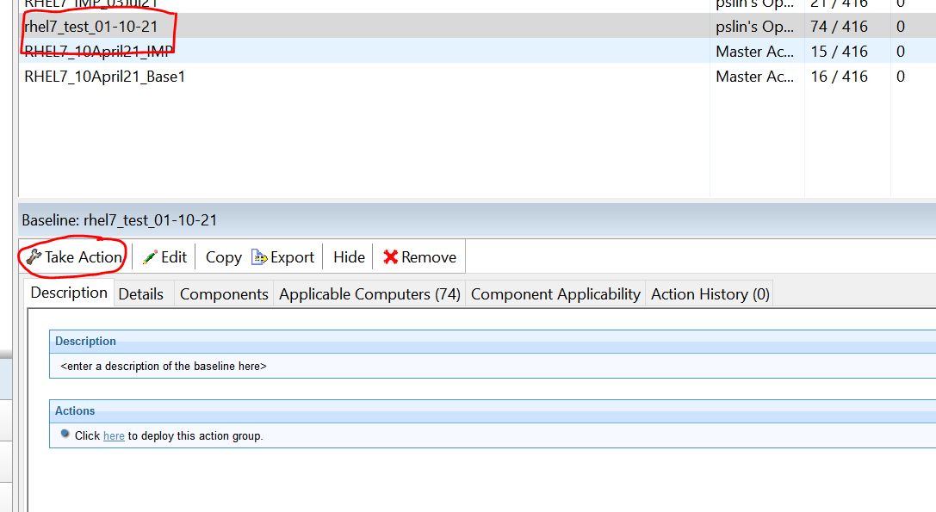

Here you can select the servers by 3 ways as below,best practice to patch multiple server of same OS is to enter the device names.

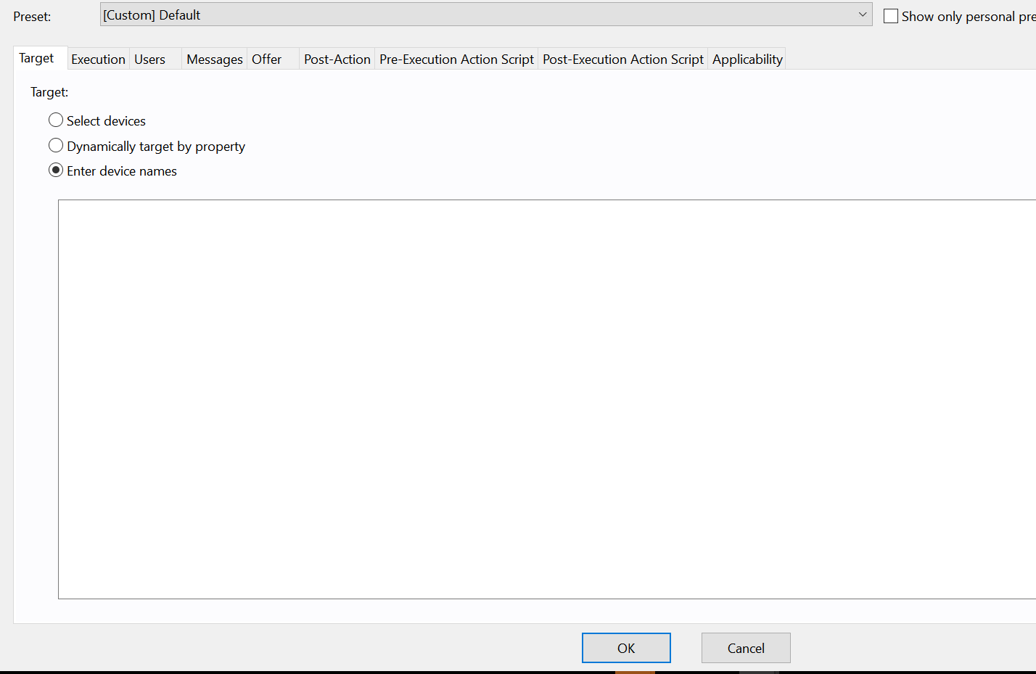

Once you enter the names then click on execution tab, select start and end time also click the check box for “ **Start client download before contraints are satisfied”** as mentioned earlier.

Now you can see the progress of your patching in action tab.

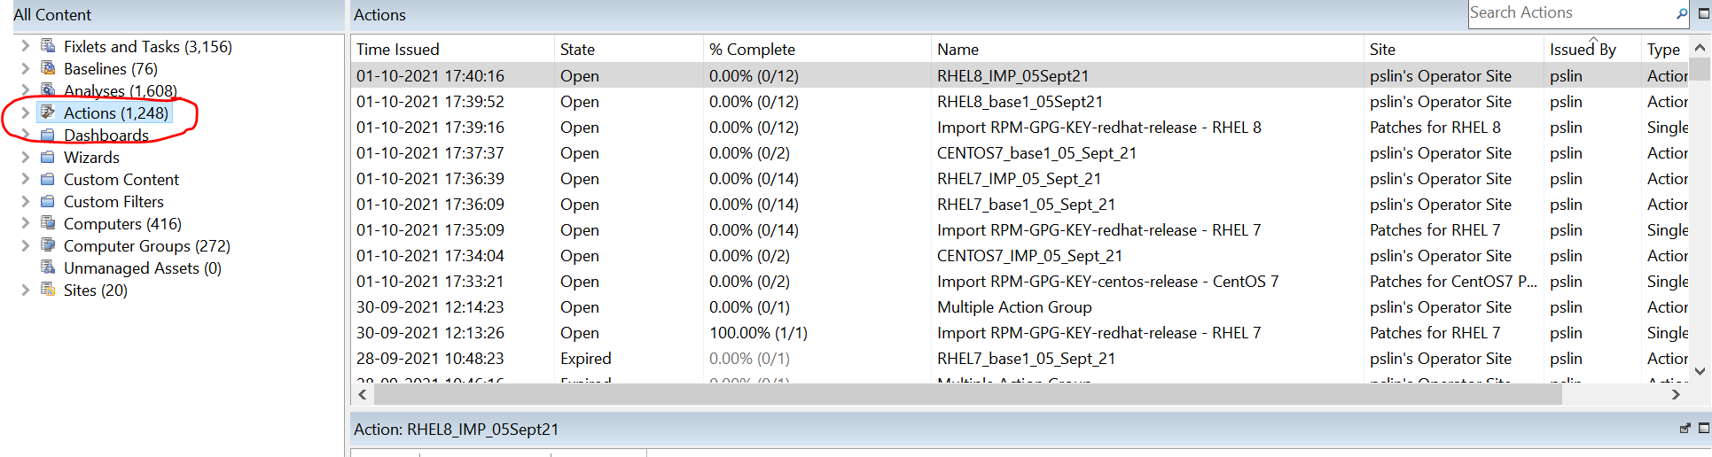

### This completes the patch deployment and baseline

### creation Document on Linux systems.